GET Car Details with JPQL Query

**Overview:**

Get the car details using JPQL Query operations.

**Functional Requirements:**

* Build an application for getting student details.
* Have to create a folder named “Controllers” inside the springapp in src.
* Inside the Controllers create a java file named “ApiController.java”.
* Next have to create the same inside the springapp named as “Models”.
* Inside Models, you should create the java file named “Car .java”.
* And create Repositories folder and inside that create "CarRepo.java"
* Create 7 variables
* 1. id - int
* 2. carName- string
* 3. carType- string
* 4. owners- int
* 5. currentOwnerName- string
* 6. mobile- long
* 7. address- string
* as well as create getters and setters and constructors for the corresponding variables.
* Finally, create the "Service" folder, and inside that create the "ApiService.java" file.
* The project structure looks like this image

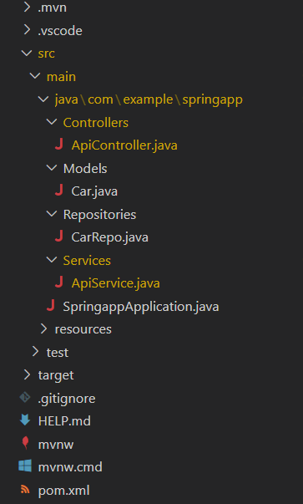

**Core Platform**

OpenJDK 11

**API:**

POST - "/"

GET- "/owners/{owners}"

GET - "/address/{address}"

GET- "/carname/{carname}"

GET- "/owners/{owners}/cartype/{cartype}"

**API endpoint:**

8080

**Platform Guidelines:**

To run the command use **Terminal**in the platform.

**Spring Boot:**

To start/run the application '**mvn spring-boot:run**'